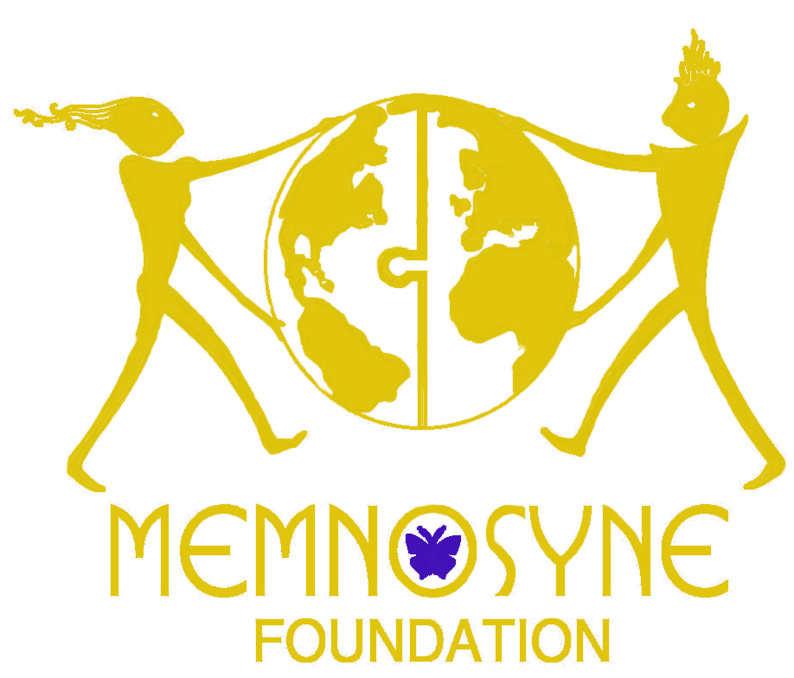

SPIRITUAL LEADER RICARDO CERVANTES CERVANTES
TO ATTEND THE SEEDS OF COMPASSION GATHERING

* Ricardo Cervantes Cervantes is the only Latin American indigenous spiritual leader that has been invited to the conference, to be presided by His Holiness the Dalai Lama

SEATTLE (April 8, 2008) - Ricardo Cervantes Cervantes, Tlahuizcalpantecutli, spiritual leader of the Toltec indigenous community of Teotihuacán, has been invited to join His Holiness The Dalai Lama and others as sole representative of Latin America's –not just Mexico's-- indigenous communities to the Seeds of Compassion gathering, where he will join others to instill compassion in the children of the world.
This invitation was possible through the intervention of Lama Tenzin Dhonden, the Dalai Lama's emissary for peace, who met Cervantes Cervantes during a visit to Teotihuacán, where he witnessed first-hand Ricardo's work aimed at helping his community's children, as well as the efforts of the Kirlin Charitable Foundation's Daniel Kranzler, who is a member of the Seeds of Compassion Organizing Committee.
The Memnosyne Foundation, based in Dallas, Texas, will sponsor Ricardo's trip to Seattle through its “Ambassadors Program.” Its Founder, Mary Ann Thompson-Frenk, says. "Lama Tenzin's invitation to Ricardo Cervantes Cervantes to attend the Seeds of Compassion conference as his honored guest and as an officially recognized Ambassador of the Toltec People of Teotihuacan, is not only beautiful in itself, but is also significant in how it will bring the public's awareness towards the incredible insight, wisdom, and spirituality that his and other indigenous cultures possess."
-MORE-

Memnosyne Foundation/Seeds of Compassion/Page Two
“Our cultural roots grow from a beautiful love that has allowed us to build wonderful homes where we as a community live together and teach each other how we can respect each other and create harmony in our lives,” says Cervantes Cervantes. “Love, energy, and culture is the knowledge which is the true symbol of power, the holy fire of the medicine, that we have taken to the mountains in the past, teaching us how we can help people learn to be good brothers with anyone in the world. This “education” is remembered in the towns of my people, and needs to be shared with those who have lost this understanding: Learn to make your place in the world a house for sharing love – not war; carry dignity in your heart and in your words – this is the best medicine for the people; the High Compromise that must you remember is that if you teach a child something, they will share it with others on the road of life. Therefore, the most important thing to teach children is how to carry love, compassion and harmony in their hearts.”
“I am very grateful to know that a Mexican indigenous leader, such as Ricardo Cervantes Cervantes, will participate in this important meeting in Seattle with spiritual leaders from all over the world, including the Dalai Lama. This is a symbol of recognition and respect for our nation's ancient traditions,” said Adolfo Ayuso Audry, Mexico's consul for Cultural Affairs in Dallas and a key contributor towards making Ricardo's trip to the US a reality.
In turn, Gregory Gomez, from the Indigenous Institute of The Americas and spiritual leader of New Mexico's Apache, expressed his views on this invitation: “As an Apache Indian it is an Honor and Privilege for me to know Ricardo Cervantes, traditional leader of the Tolteca people of Teotihuacan. We have shared cultural, spiritual and ceremonial traditions of our peoples. I am so proud he has been selected by Creator, invited by the Dali Lama and accepted to represent the Indigenous peoples of the
Americas in Seattle, Washington. We're also looking forward to his visits on the Reservations and urban areas with people who are willing and ready to listen, learn and share with him.”
-MORE-

Memnosyne Foundation/Seeds of Compassion/Page Three
The Seeds of Compassion conference will take place April 11 - 15 in Seattle, Washington. The event is an unprecedented gathering to engage the hearts and minds of our community by highlighting the vision, science, and programs of early social, emotional, and cognitive learning. Presented by His Holiness the Dalai Lama, The Seeds of Compassion event will explore the relationships, programs and tools that nurture and empower thousands of children, families and communities to be compassionate members of society. For more information about Seeds of Compassion, visit www.seedsofcompassion.net
ABOUT THE MEMNOSYNE FOUNDATION: The Mission of the Memnosyne Foundation is to provide mankind the means to encourage positive, peaceful global collaboration in all areas of knowledge. This is being achieved by its ongoing global programs and its creation of the campuses, the first of which will be located in Dallas, TX.
Visit www.memnosyne.org for further information.

PRESS CONTACT:
John S. Shore
Shore Public Relations
Dallas, Texas
214-352-5111, direct
214-738-1516, cell, 24-hours, during conference in Seattle

