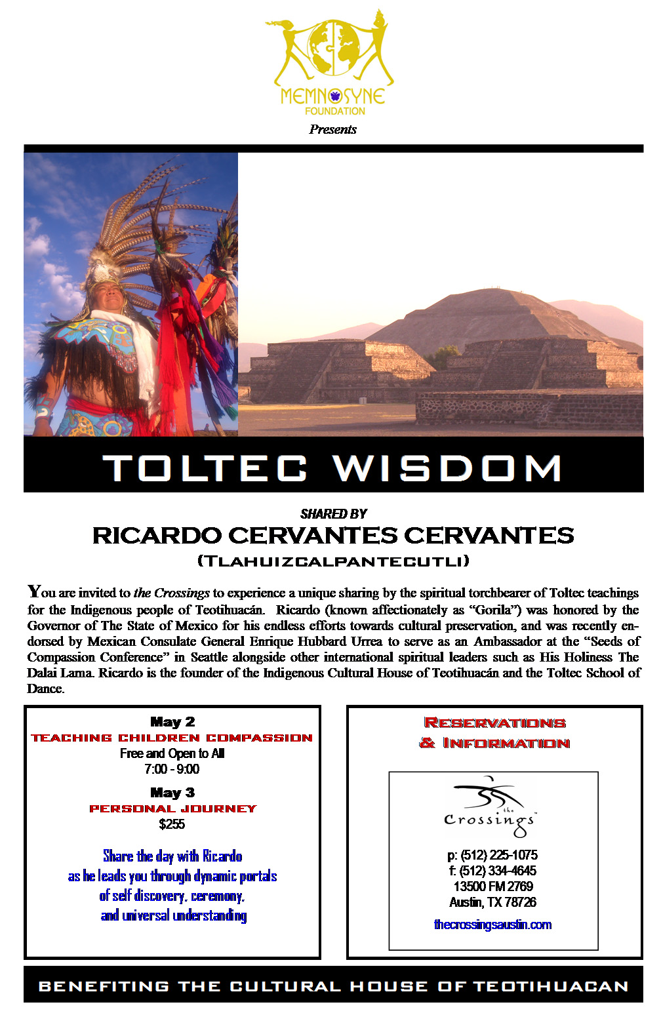

Ricardo Cervantes
at

The Crossings

Toltec Wisdom: Teaching Children Compassion
Friday Night

In an accelerated world where value systems are turned upside down and reality is besieged by conflict, violence, and fear, now more than ever, children need a sincere, humane ability to create the balance they will need for happiness and success in life. Compassion, the desire to reach out to help others who are suffering, can be a key to personal growth in children and instills in them a heightened sense to create a more peaceful world.

Ricardo Cervantes Cervantes (Tlahuizcalpantecutli), spiritual leader of the Toltec indigenous community of Teotihuacán, was invited to join His Holiness The Dalai Lama and others as the sole representative of Latin America's indigenous communities to the Seeds of Compassion gathering to instill compassion in the children of the world.

Ricardo will share with the audience how the Toltec embrace their children and plant seeds of compassion, resulting in a beautiful love of self, community, and all livings things.

“My representatives have given me the responsibility to plant seed of the love flower energy into the hearts of children and people who come to our House of Medicine “Teotihuacan.: When Spaniards mixed with my people we learmed that there are other kinds of medicine for the heart, but we also learned that both medicines can exist in harmony together. This is what I teach to my people and this is the medicine that I am coming to share with the people in the places I will visit in the United States.”

Toltec Wisdom: Self Discovery
Saturday

Suffering through the conquest of the Aztec and Spanish conquistadors, the Toltec community secretly preserved their traditions and sacred knowledge for centuries by selecting trusted individuals to dedicate their life to the preservation of their culture and their sacred ways. Ricardo is entrusted with this sacred responsibility and for the first time in the United States during this golden age of enlightenment is here to share Toltec Wisdom.

Ricardo will journey with 40 people at the Crossings through the vortex of the past, present, and future as he shares important Toltec knowledge. This group of people will be the first to gather as journeymen with Ricardo in the US as he unveils his teachings. It will be a day of insight, discovery, healing, and transformation.

Morning

Awakening the Soul
- Greeting the day with energy and uncommon potential
- Receive the Fire and Blessings from Teotihuacán
Journey through Teotihuacán: The Place where Humans Become as God
- Learn the history of the ancient pyramids of Teotihuacán and its people
- Understand Teotihuacán sacred cosmic energy
Quetzalcoatl: the Plumed Serpent
- The Man & the Myth
The Toltec Path
- Creating Heaven on earth
The Mesoamerican Calendar: On the Threshold of Tomorrow
- Receiving of Indian names

Afternoon

Drinking Sunlight
- Pulling energy from the Sun

Fire Ceremony
- Experience Ancient Toltec Fire Ceremony that ignites the ancient medicine
Teachings: Opening the heart to receive White Warrior Medicine and the Seven Sacred Roads of Life
- Language
- Philosophy
- Music
- Art
- Love
- Education
- Freedom

Embracing the Eagle Spirit & Jaguar Warrior
Individual Awakenings
- Receive personal insight and awakenings for remembering who you really are

Late Afternoon

Temazan Bath (House of the Medicine Steam)
- An opportunity for self discovery, cleansing, healing, and awakening
- Connecting with Creator

Dance of the New Fire
Sunset Ceremony
Circle of Intent: Going Forth

