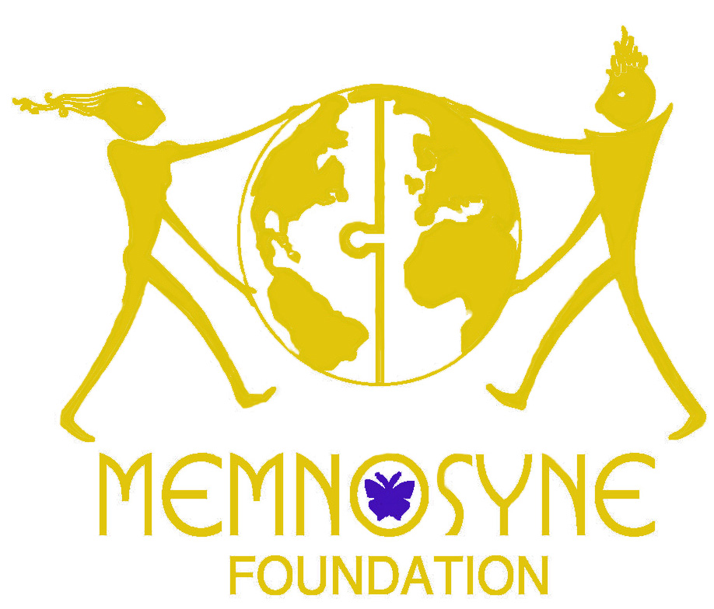
MEMNOSYNE FOUNDATION’S VISION FOR A SUSTAINABLE FUTURE: Environmental Series
3-Event Series Facilitated in Orbits of Influence Dialogue & Vision Circles
Each Event will include discussion forums, a featured speaker and the information generated will be utilized by The Memnosyne Foundation in its future programs, events and sponsorships.
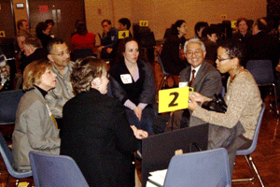
First Event in 3-Event Environmental Series:
A guided dialogue and visioning series, bringing together leading voices from environmental groups and eco-conscious citizens like you to address key regional environmental issues and to generate a shared agenda for collective influence and action around common goals.
CLEAN WATER: VISION FOR A SUSTAINABLE FUTURE
Thursday, June 19, 2008 - 5:30-8:30 p.m.
Richland College/DCCCD (12800 Abrams Road, Dallas, TX 75243)
Attire: Business / Business Casual * Gourmet coffee and light refreshments served.
• Be Part of the Leadership Conversation! Participant Admission - Only $10!
Summer Special: Bring a Guest for Half Price only $5! So be sure to invite all your Visionary friends to join you!
Advance Registration/RSVP Required. [At-the-Door Admission - $15 per Participant]
• CLEAN WATER • CLEAN AIR • GREEN TECHNOLOGY
Memnosyne Foundation The Mission of The Memnosyne Foundation is to provide mankind with the means to encourage positive, peaceful global collaboration in all areas of knowledge. This is being achieved via our ongoing global programs and via the creation of campuses, the first of which will be located in Dallas, Texas, USA. The Vision of The Memnosyne Foundation is to help the diverse people of the the world consciously encourage an evolution for themselves and for future generations.
Orbits of Influence
is an innovative, inclusive leadership dialogue initiative, designed to enable all participants to expand their personal, Career, social and community connections beyond their existing realms of influence, to exchange ideas and address shared issues.

